
Company
Logotype

Cone Beam Computed Tomography- Report



Porur Dental X-rays & CBCT

Patient Name : Mr. Sunil | Date of Report : 22.06.2024
Age/ Gender : 47 years/ Male | Region of Interest : CBCT Mandible
Referring doctor:32 Dental Madhananthapuram | Indication : Implant assessment
Clinical Notes: Nil
PATIENT INFORMATION

CBCT- Mandible provided
CBCT – IMAGE DETAILS

RADIOGRAPHIC INTERPRETATION

- Completely missing crown and root portion in relation to 46, 47.
- The mandibular alveolar ridge is present with normal trabecular pattern.
- Root stump: 37
- Crown in relation to : 36
- Restored: 48

IMPLANT ASSESSMENT

 | 35 region | 36 region | 37 region
Sub-Crestal (in mm) | 8.05 | 10.35 | 6.15
Mid- Crestal (in mm) | 8.26 | 12.25 | 8.68
Distance between alveolar ridge and the inferior alveolar nerve canal (in mm) | 14.16 | 17.74 | 19.96
Distance between alveolar ridge and the inferior border of mandible (in mm) | 28.74 | 28.75 | 26.18
 | 45 region | 46 region | 47 region
Sub-Crestal (in mm) | 5.92 | 5.92 | 6.87
Mid- Crestal (in mm) | 9.52 | 9.52 | 9.58
Distance between alveolar ridge and the inferior alveolar nerve canal (in mm) | 20.59 | 20.59 | 20.7
Distance between alveolar ridge and the inferior border of mandible (in mm) | 28.83 | 28.83 | 27.85

RADIOGRAPHIC IMPRESSION

- Partially edentulous mandibular alveolar ridge.
- Root stump: 37
- Crown in relation to : 36
- Restored: 48

Kindly correlate with clinical findings


IMAGES FOR REFERENCE

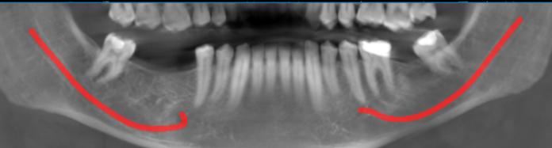
RECONSTRUCTED PANORAMIC VIEW

3-DIMENSIONAL VIEW

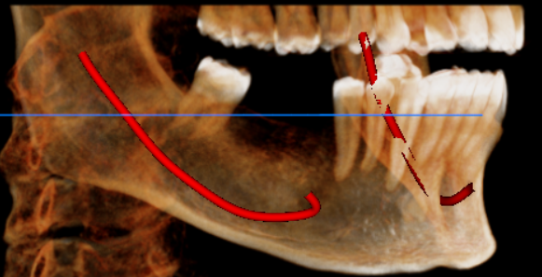
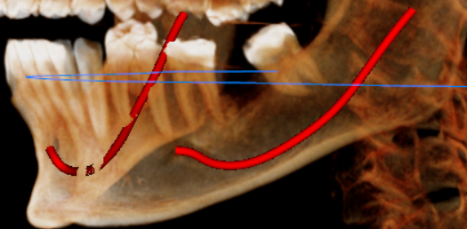

CROSS SECTIONAL VIEW

35 region | 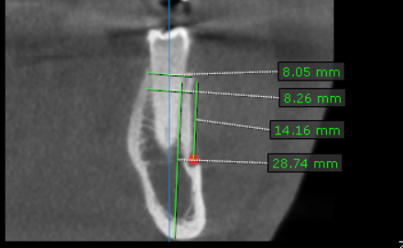
36 region | 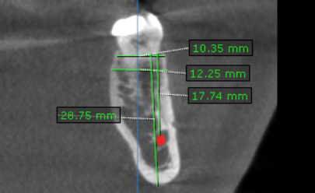
37 region | 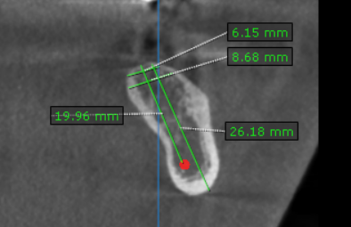
45 region | 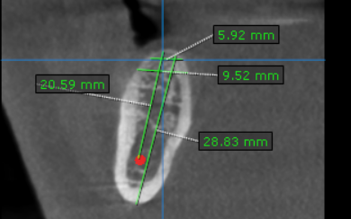
46 region | 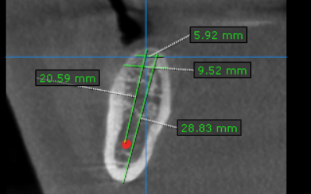
47 region | 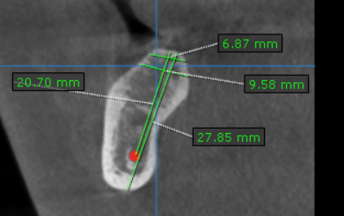

**** End of report ****

